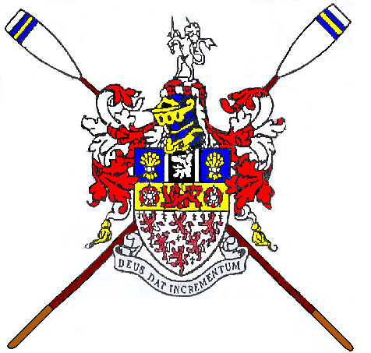

Warrington Rowing Club Nomination Form 2018

Please read the attached details before completing the form.
According to the club constitution anyone who proposes or seconds a nominee must be a paid up member of WRC, membership must be a minimum of 6 months. Junior members are not entitled to vote.
Anyone who is nominated for a committee role and is successful must be a club member or will need to be prepared to become a club member following their election.
The nomination form is below, please complete it and place in the club secretary’s file at club house.
Alternatively, return the form to the secretary electronically.
Forms must be returned by Sunday 2nd September 2018
A list of all nominations will be circulated to the membership by Wednesday 5th September 2018
The AGM is scheduled for Wednesday 12th September 2018 at 7pm in the club room.
If you have any questions, please contact me via Warringtonrowingclub@gmail.com
Regards
Jon Budd
Club Secretary

Role: ..........................................................
 | Name  (printed) | Signature | Telephone Number
Nominee

Proposed by

Seconded by

